**Contributions in release 2:**

In release 2, I created other 5 new pages, modified and added more details existing pages in release 1. The 5 new pages are FAQ, instruction, about us, personal profile and setting. I also created desktop view and mobile view of each page. Meanwhile, I found some free CSS and JavaScript code on the internet used to improve the performance of UI.

After finishing coding, I will do white box testing to make sure that the UI is good and connection between each page and php code is good, as well as data refreshing. This is a very important and time-consuming task for me to debugging. So I need to throw myself into this task. During coding, I also need to change the UI synchronous, because my UI needs to cater to the team members’ requirements who were writing PHP code and SQL code.

Some screen shot of UI are placed below, with some brief descriptions. The source code of five aspects will be placed in my folder (ZHENGJIE YANG N9327754) in branch release 2 in github. Some CSS and JavaScript code will be placed in source code folder. If you would like to see the whole performance of UI, please copy the html file with CSS and JavaScript in the same folder.

**About team dynamic:**

I am mainly responsible for the user interface of the application. This required me to design the UI first, then find some resources on the Internet, then write codes. During each team meeting held weekly, all team members came out with their ideas of UI. I recorded them and made them on the screen.

What’s more, as the project manager, I booked the meeting room and kept every team member in the loop, I also communicated with client team in order to meet client’s requirements. All team members kept updating user stories, team blog and release plans to make the project continue smoothly. During peer review, we shared our ideas of developer team’s application performance and let Mike and Averson to write the peer review letter. We use github, google drive and Wechat to share files and communicate instantly as well.

1. FAQ

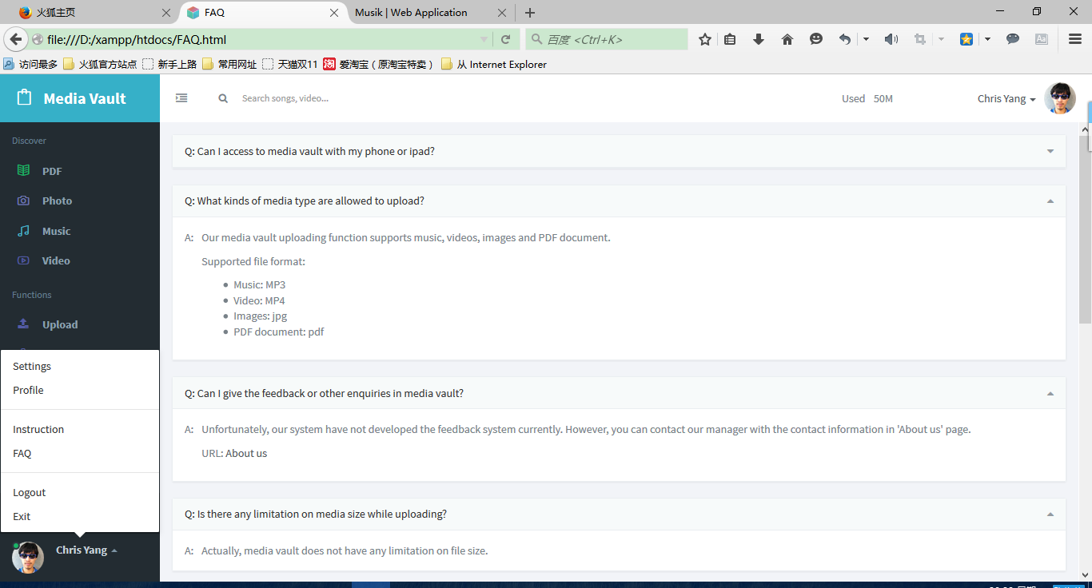

Description: This page shows the most frequent questions created by users. Users can collapse the collapsible box if they want.

1. Instruction

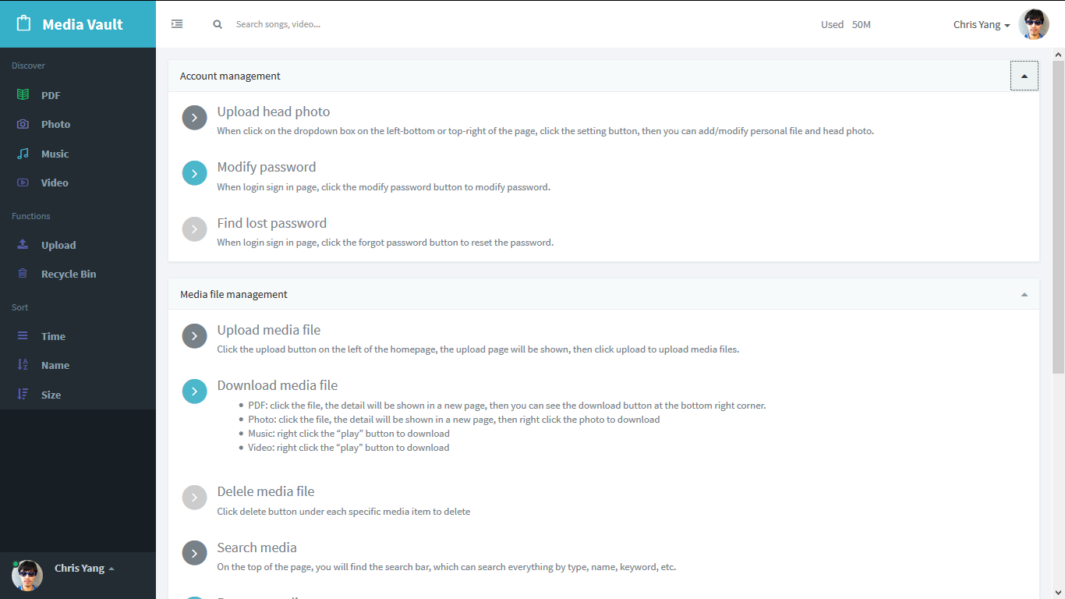

Description: This page shows the user menu. It tells users how to use media vault. Users can collapse the collapsible box if they want.

1. Personal profile

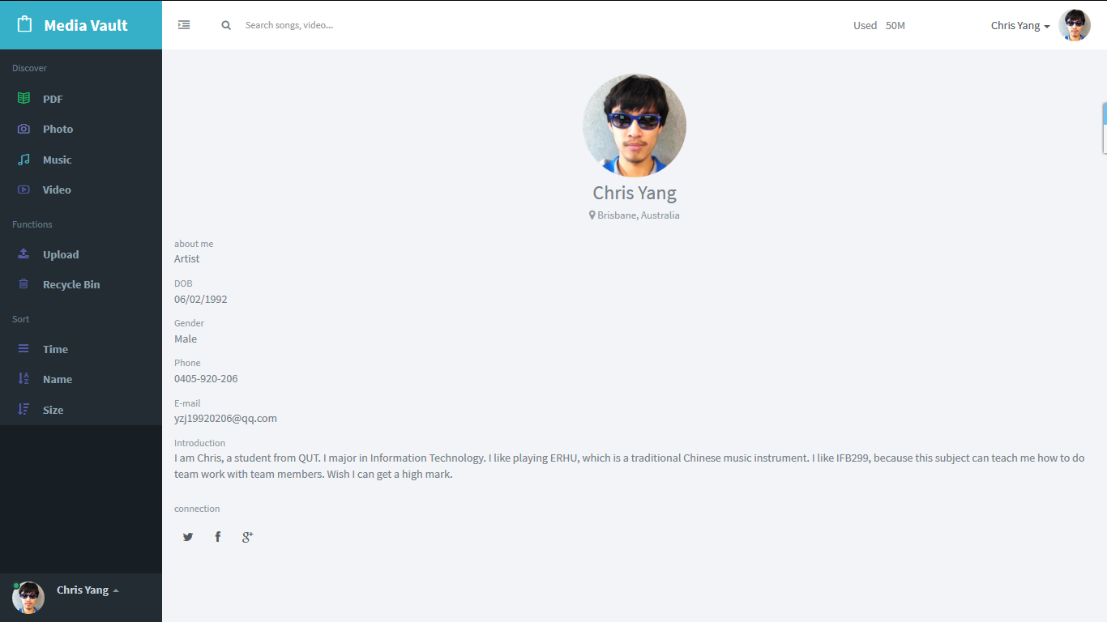

Description: This page shows the personal profiles, which includes name, head photo, city, country, occupation, DOB, phone number, email, gender and introduction.

1. setting

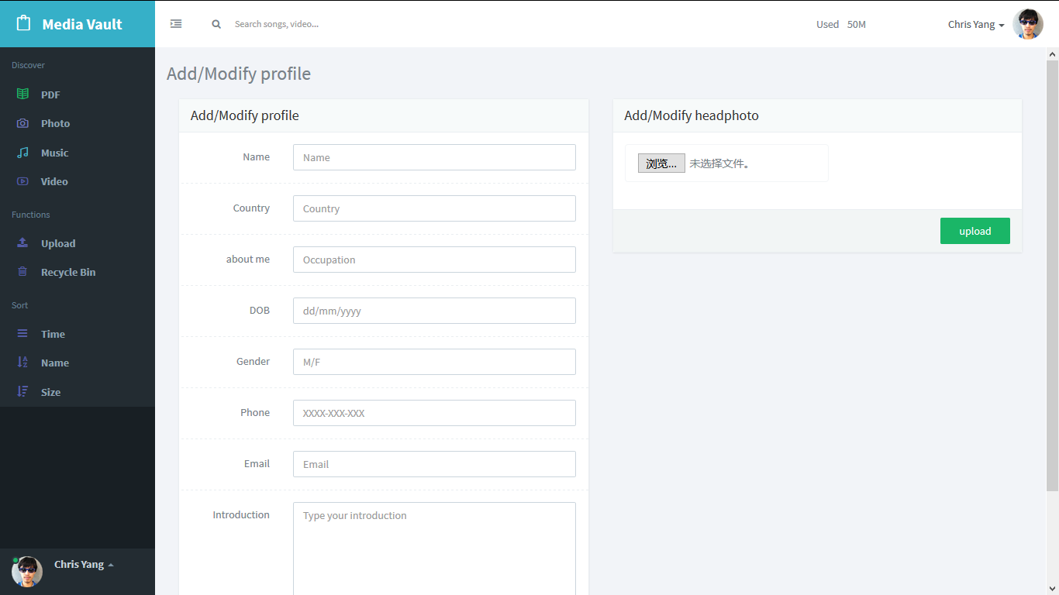

Description: This page can let user to add and modify detailed profile information and head photo.

1. About us

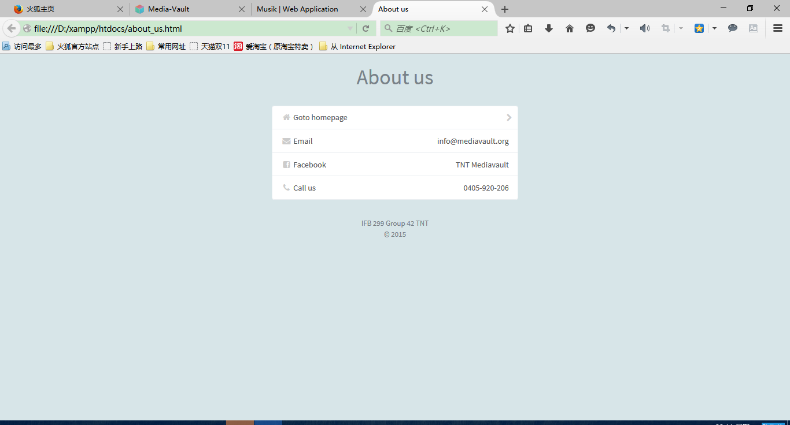

Description: This page shows the developers’ (TNT Media vault) contact details including email, Facebook and phone number.

6． All UI have both desktop view and mobile view. Below are some examples.

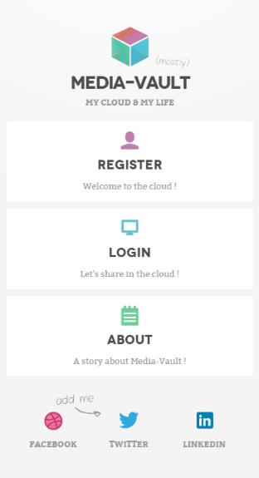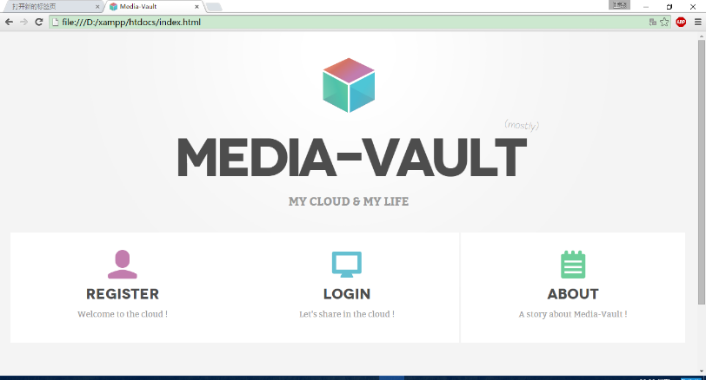

Welcome page (desktop)

Welcome page (mobile)

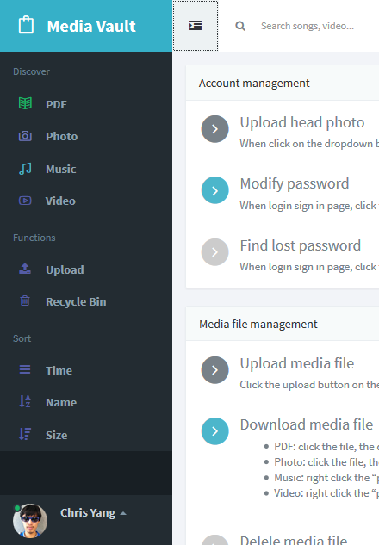 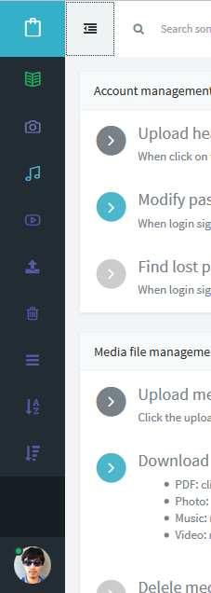

User can collapse the main menu (desktop).

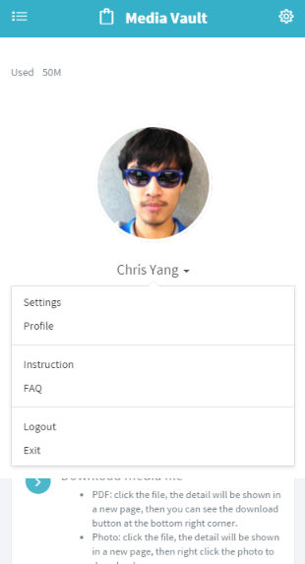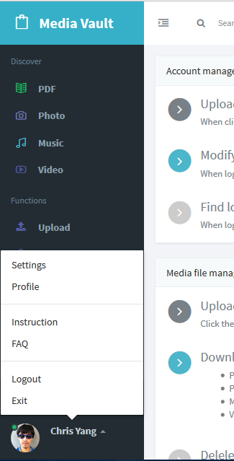

Shortcut menu (desktop) Shortcut menu (mobile)

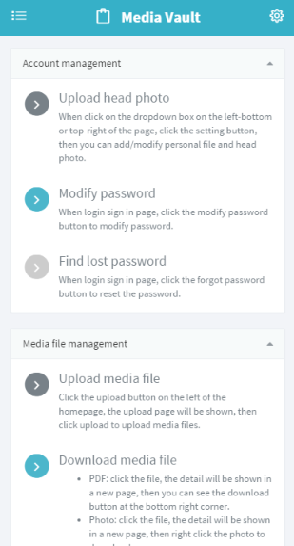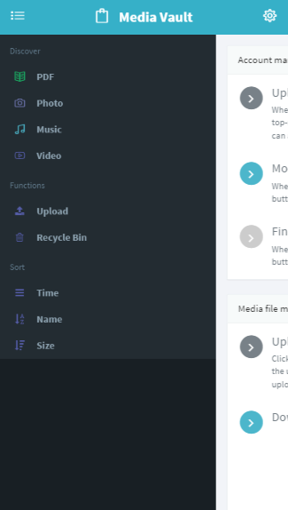

Main menu (mobile) Instruction page (mobile)